1. **Create a Spring Web Project using Maven**

**SpringLearnApplication.java:**

package com.cognizant.spring_learn;

import org.slf4j.Logger;

import org.slf4j.LoggerFactory;

import org.springframework.boot.SpringApplication;

import org.springframework.boot.autoconfigure.SpringBootApplication;

import org.springframework.context.ApplicationContext;

import org.springframework.context.support.ClassPathXmlApplicationContext;

import com.cognizant.spring_learn.model.Country;

@SpringBootApplication

public class SpringLearnApplication

{

private static final Logger LOGGER = LoggerFactory.getLogger(SpringLearnApplication.class);

public static void main(String[] args) {

SpringApplication.run(SpringLearnApplication.class, args);

LOGGER.info("START of main()");

ApplicationContext context = new ClassPathXmlApplicationContext("country.xml");

Country country = (Country) context.getBean("country");

LOGGER.debug("Country: {}", country.toString());

LOGGER.info("END of main()");

}

}

**application.properties:**

spring.application.name=spring-learn

logging.level.root=INFO

logging.level.com.cognizant=DEBUG

logging.pattern.console=%d{yyyy-MM-dd HH:mm:ss} - %msg%n

**HelloController.java:**

package com.cognizant.springlearn;

import org.springframework.web.bind.annotation.GetMapping;

import org.springframework.web.bind.annotation.RestController;

*@RestController*

public class HelloController

{

*@GetMapping*("/hello")

public String sayHello()

{

return "Hello from Spring Boot!";

}

}

**Result:**

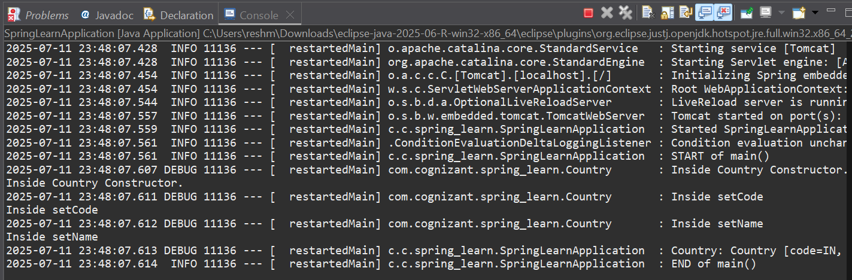

1. **Spring Core – Load Country from Spring Configuration XML**

**pom.xml:**

<?xml version="1.0" encoding="UTF-8"?>

<project xmlns="http://maven.apache.org/POM/4.0.0" xmlns:xsi="http://www.w3.org/2001/XMLSchema-instance"

xsi:schemaLocation="http://maven.apache.org/POM/4.0.0 https://maven.apache.org/xsd/maven-4.0.0.xsd">

<modelVersion>4.0.0</modelVersion>

<parent>

<groupId>org.springframework.boot</groupId>

<artifactId>spring-boot-starter-parent</artifactId>

<version>3.5.3</version>

<relativePath/>

</parent>

<groupId>com.cognizant</groupId>

<artifactId>spring-learn</artifactId>

<version>0.0.1-SNAPSHOT</version>

<name>spring-learn</name>

<description>Demo project for Spring Boot</description>

<url/>

<licenses>

<license/>

</licenses>

<developers>

<developer/>

</developers>

<scm>

<connection/>

<developerConnection/>

<tag/>

<url/>

</scm>

<properties>

<java.version>17</java.version>

</properties>

<dependencies>

<dependency>

<groupId>org.springframework.boot</groupId>

<artifactId>spring-boot-starter-web</artifactId>

</dependency>

<dependency>

<groupId>org.springframework.boot</groupId>

<artifactId>spring-boot-devtools</artifactId>

<scope>runtime</scope>

<optional>true</optional>

</dependency>

<dependency>

<groupId>org.springframework.boot</groupId>

<artifactId>spring-boot-starter-test</artifactId>

<scope>test</scope>

</dependency>

</dependencies>

<build>

<plugins>

<plugin>

<groupId>org.springframework.boot</groupId>

<artifactId>spring-boot-maven-plugin</artifactId>

</plugin>

</plugins>

</build>

</project>

**SpringLearnApplication.java:**

package com.cognizant.spring_learn;

import org.slf4j.Logger;

import org.slf4j.LoggerFactory;

import org.springframework.boot.autoconfigure.SpringBootApplication;

import org.springframework.boot.SpringApplication;

import org.springframework.context.ApplicationContext;

import org.springframework.context.support.ClassPathXmlApplicationContext;

@SpringBootApplication

public class SpringLearnApplication

{

private static final Logger LOGGER = LoggerFactory.getLogger(SpringLearnApplication.class);

public static void main(String[] args)

{

SpringApplication.run(SpringLearnApplication.class, args);

displayCountry();

}

public static void displayCountry()

{

LOGGER.info("START displayCountry()");

System.out.println("START displayCountry()");

ApplicationContext context = new ClassPathXmlApplicationContext("country.xml");

Country country = context.getBean("country", Country.class);

LOGGER.debug("Country : {}", country.toString());

System.out.println("Country: " + country);

LOGGER.info("END displayCountry()");

System.out.println("END displayCountry()");

}

}

**application.properties:**

spring.application.name=spring-learn

logging.level.root=INFO

logging.level.com.cognizant=DEBUG

server.port=8082

server.port=0

**Country.java:**

package com.cognizant.spring_learn;

import org.slf4j.Logger;

import org.slf4j.LoggerFactory;

public class Country

{

private static final Logger ***LOGGER*** = LoggerFactory.*getLogger*(Country.class);

private String code;

private String name;

public Country()

{

***LOGGER***.debug("Inside Country Constructor.");

System.***out***.println("Inside Country Constructor.");

}

public String getCode()

{

***LOGGER***.debug("Inside getCode");

System.***out***.println("Inside getCode");

return code;

}

public void setCode(String code)

{

***LOGGER***.debug("Inside setCode");

System.***out***.println("Inside setCode");

this.code = code;

}

public String getName()

{

***LOGGER***.debug("Inside getName");

System.***out***.println("Inside getName");

return name;

}

public void setName(String name)

{

***LOGGER***.debug("Inside setName");

System.***out***.println("Inside setName");

this.name = name;

}

*@Override*

public String toString()

{

return "Country [code=" + code + ", name=" + name + "]";

}

}

**Country.xml:**

<?xml version="1.0" encoding="UTF-8"?>

<beans xmlns="http://www.springframework.org/schema/beans"

xmlns:xsi="http://www.w3.org/2001/XMLSchema-instance"

xsi:schemaLocation="http://www.springframework.org/schema/beans

https://www.springframework.org/schema/beans/spring-beans.xsd">

<bean id="country" class="com.cognizant.spring_learn.Country">

<property name="code" value="IN"/>

<property name="name" value="India"/>

</bean>

</beans>

**Result:**

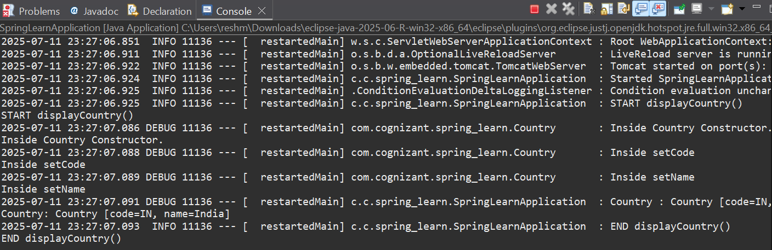

1. **Hello World RESTful Web Service**

**SpringLearnApplication.java:**

package com.cognizant.spring_learn;

import org.springframework.boot.SpringApplication;

import org.springframework.boot.autoconfigure.SpringBootApplication;

*@SpringBootApplication*

public class SpringLearnApplication

{

public static void main(String[] args)

{

SpringApplication.*run*(SpringLearnApplication.class, args);

}

}

**pom.xml:**

<?xml version="1.0" encoding="UTF-8"?>

<project xmlns="http://maven.apache.org/POM/4.0.0"

xmlns:xsi="http://www.w3.org/2001/XMLSchema-instance"

xsi:schemaLocation="http://maven.apache.org/POM/4.0.0

http://maven.apache.org/xsd/maven-4.0.0.xsd">

<modelVersion>4.0.0</modelVersion>

<groupId>com.cognizant</groupId>

<artifactId>spring-learn</artifactId>

<version>0.0.1-SNAPSHOT</version>

<name>spring-learn</name>

<description>Demo project for Spring Boot - Hello World REST API</description>

<packaging>jar</packaging>

<parent>

<groupId>org.springframework.boot</groupId>

<artifactId>spring-boot-starter-parent</artifactId>

<version>2.7.13</version> <relativePath/> </parent>

<properties>

<java.version>11</java.version> </properties>

<dependencies>

<dependency>

<groupId>org.springframework.boot</groupId>

<artifactId>spring-boot-starter-web</artifactId>

</dependency>

<dependency>

<groupId>org.springframework.boot</groupId>

<artifactId>spring-boot-devtools</artifactId>

<scope>runtime</scope>

<optional>true</optional>

</dependency>

<dependency>

<groupId>org.springframework.boot</groupId>

<artifactId>spring-boot-starter-test</artifactId>

<scope>test</scope>

</dependency>

</dependencies>

<build>

<plugins>

<plugin>

<groupId>org.springframework.boot</groupId>

<artifactId>spring-boot-maven-plugin</artifactId>

</plugin>

</plugins>

</build>

</project>

**HelloController.java:**

package com.cognizant.spring_learn.controller;

import org.slf4j.Logger;

import org.slf4j.LoggerFactory;

import org.springframework.web.bind.annotation.*;

*@RestController*

public class HelloController

{

private static final Logger ***LOGGER*** = LoggerFactory.*getLogger*(HelloController.class);

*@GetMapping*("/hello")

public String sayHello()

{

***LOGGER***.info("START: sayHello()");

String message = "Hello World!!";

***LOGGER***.info("END: sayHello()");

return message;

}

}

**application.properties:**

spring.application.name=spring-learn

logging.level.root=INFO

logging.level.com.cognizant=DEBUG

server.port=8082

server.port=0

server.port=8080

**Result:**

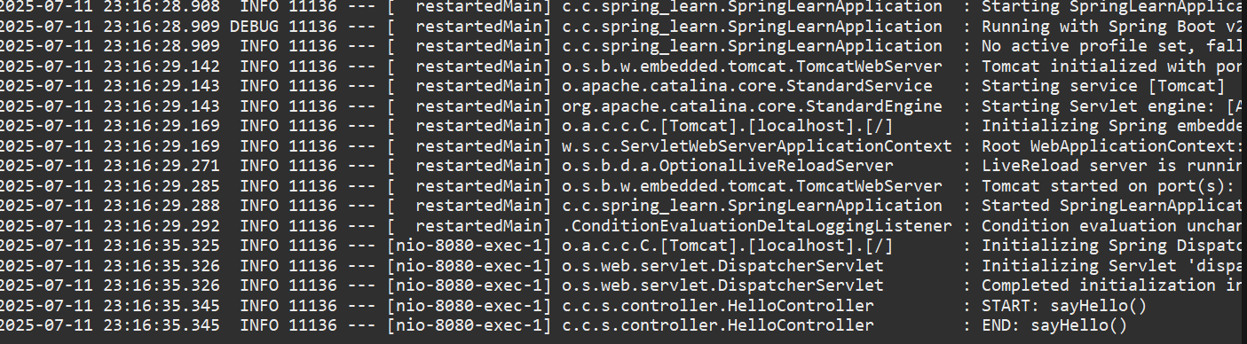

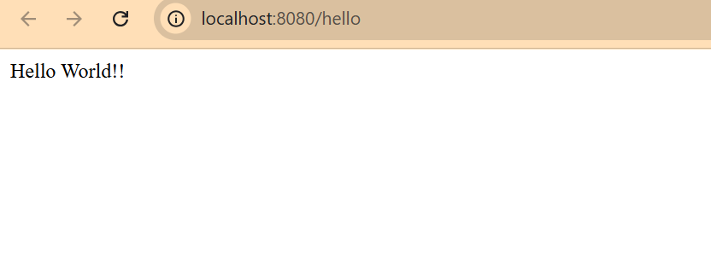

1. **REST - Country Web Service**

**SpringLearnApplication.java:**

package com.cognizant.spring_learn;

import org.springframework.boot.SpringApplication;

import org.springframework.boot.autoconfigure.SpringBootApplication;

import org.springframework.context.annotation.ComponentScan;

*@SpringBootApplication*

*@ComponentScan*(basePackages = "com.cognizant.spring_learn")

public class SpringLearnApplication

{

public static void main(String[] args)

{

SpringApplication.*run*(SpringLearnApplication.class, args);

}

}

**Country.java:**

package com.cognizant.spring_learn;

public class Country

{

private String name;

private String code;

public String getName()

{

return name;

}

public void setName(String name)

{

this.name = name;

}

public String getCode()

{

return code;

}

public void setCode(String code)

{

this.code = code;

}

}

**Country.xml:**

<?xml version="1.0" encoding="UTF-8"?>

<beans xmlns="http://www.springframework.org/schema/beans"

xmlns:xsi="http://www.w3.org/2001/XMLSchema-instance"

xsi:schemaLocation="http://www.springframework.org/schema/beans

http://www.springframework.org/schema/beans/spring-beans.xsd">

<bean id="country" class="com.cognizant.spring_learn.Country">

<property name="name" value="India"/>

<property name="code" value="IN"/>

</bean>

</beans>

**CountryController.java:**

package com.cognizant.spring_learn.controller;

import org.springframework.context.ApplicationContext;

import org.springframework.context.support.ClassPathXmlApplicationContext;

import org.springframework.web.bind.annotation.RequestMapping;

import org.springframework.web.bind.annotation.RestController;

import com.cognizant.spring_learn.Country;

*@RestController*

public class CountryController

{

*@RequestMapping*("/country")

public Country getCountryIndia()

{

ApplicationContext context = new ClassPathXmlApplicationContext("country.xml");

return (Country) context.getBean("country");

}

}

**application.properties:**

server.port=8083

logging.level.org.springframework=INFO

**Result:**

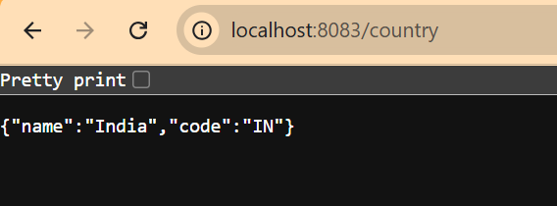

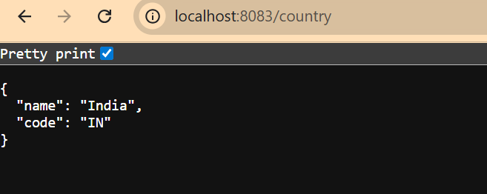

1. **REST - Get country based on country code**

**SpringLearnApplication.java:**

package com.cognizant.spring_learn;

import org.springframework.boot.SpringApplication;

import org.springframework.boot.autoconfigure.SpringBootApplication;

import org.springframework.context.annotation.ComponentScan;

*@SpringBootApplication*

*@ComponentScan*("com.cognizant.spring_learn")

public class SpringLearnApplication

{

public static void main(String[] args)

{

SpringApplication.*run*(SpringLearnApplication.class, args);

}

}

**Country.xml:**

<?xml version="1.0" encoding="UTF-8"?>

<beans xmlns="http://www.springframework.org/schema/beans"

xmlns:xsi="http://www.w3.org/2001/XMLSchema-instance"

xsi:schemaLocation="

http://www.springframework.org/schema/beans

https://www.springframework.org/schema/beans/spring-beans.xsd">

<bean id="countryList" class="java.util.ArrayList">

<constructor-arg>

<list>

<bean class="com.cognizant.spring_learn.Country">

<property name="code" value="IN"/>

<property name="name" value="India"/>

</bean>

<bean class="com.cognizant.spring_learn.Country">

<property name="code" value="US"/>

<property name="name" value="United States"/>

</bean>

</list>

</constructor-arg>

</bean>

</beans>

**CountryService.java:**

package com.cognizant.spring_learn.controller;

import jakarta.annotation.PostConstruct;

import org.springframework.beans.factory.annotation.Autowired;

import org.springframework.web.bind.annotation.*;

import com.cognizant.spring_learn.Country;

import com.cognizant.spring_learn.service.CountryService;

*@RestController*

public class CountryController

{

*@Autowired*

private CountryService countryService;

*@GetMapping*("/country/{code}")

public Country getCountry(*@PathVariable* String code)

{

return countryService.getCountry(code);

}

*@PostConstruct*

public void init()

{

System.***out***.println(">>>> CountryController loaded successfully");

}

}

**application.properties:**

server.port=9095

logging.level.org.springframework=INFO

logging.level.org.springframework.web=DEBUG

**CountryService.java:**

package com.cognizant.spring_learn.service;

import java.util.List;

import org.springframework.context.ApplicationContext;

import org.springframework.context.support.ClassPathXmlApplicationContext;

import org.springframework.stereotype.Service;

import com.cognizant.spring_learn.Country;

*@Service*

public class CountryService

{

public Country getCountry(String code)

{

ApplicationContext context = new ClassPathXmlApplicationContext("country.xml");

List<Country> countryList = (List<Country>) context.getBean("countryList");

return countryList.stream()

.filter(country -> country.getCode().equalsIgnoreCase(code))

.findFirst()

.orElse(null);

}

}

**Result:**

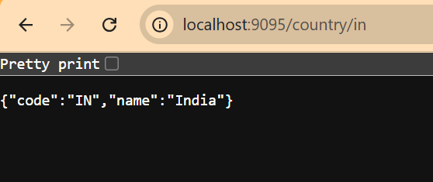

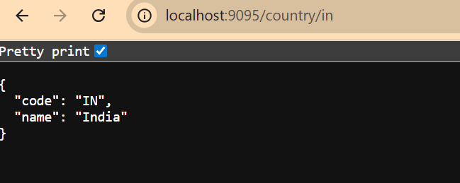

1. **Create authentication service that returns JWT**

**HomeController.java:**

package com.example.jwtauth.controller;

import org.springframework.web.bind.annotation.GetMapping;

import org.springframework.web.bind.annotation.RestController;

*@RestController*

public class HomeController {

*@GetMapping*("/")

public String home()

{

return "✅ JWT Authentication Server is running!";

}

}

**application.properties:**

server.port=8081

**JwtauthApplication.java:**

package com.example.jwtauth;

import org.springframework.boot.SpringApplication;

import org.springframework.boot.autoconfigure.SpringBootApplication;

*@SpringBootApplication*

public class JwtauthApplication

{

public static void main(String[] args)

{

SpringApplication.*run*(JwtauthApplication.class, args);

}

}

**SecurityConfig.java:**

package com.example.jwtauth.config;

import org.springframework.context.annotation.Bean;

import org.springframework.context.annotation.Configuration;

import org.springframework.security.config.annotation.web.builders.HttpSecurity;

import org.springframework.security.web.SecurityFilterChain;

*@Configuration*

public class SecurityConfig

{

*@Bean*

public SecurityFilterChain filterChain(HttpSecurity http) throws Exception

{

http

.csrf().disable()

.authorizeRequests()

.antMatchers("/").permitAll()

.anyRequest().authenticated()

.and()

.httpBasic();

return http.build();

}

}

**Result:**

